LISTING

ALGORITMA DAN PEMROGRAMAN

PERTEMUAN KE-5

PRAKTIK 1

1. Boolean variable

public class LatihanVariabelBoolean1{

public static void main(String[]args){

boolean passed, largeVenue, grade;

passed= true;

largeVenue= false;

grade= passed;

System.out.println(passed);

System.out.println(largeVenue);

System.out.println(grade);

}

}

Output:

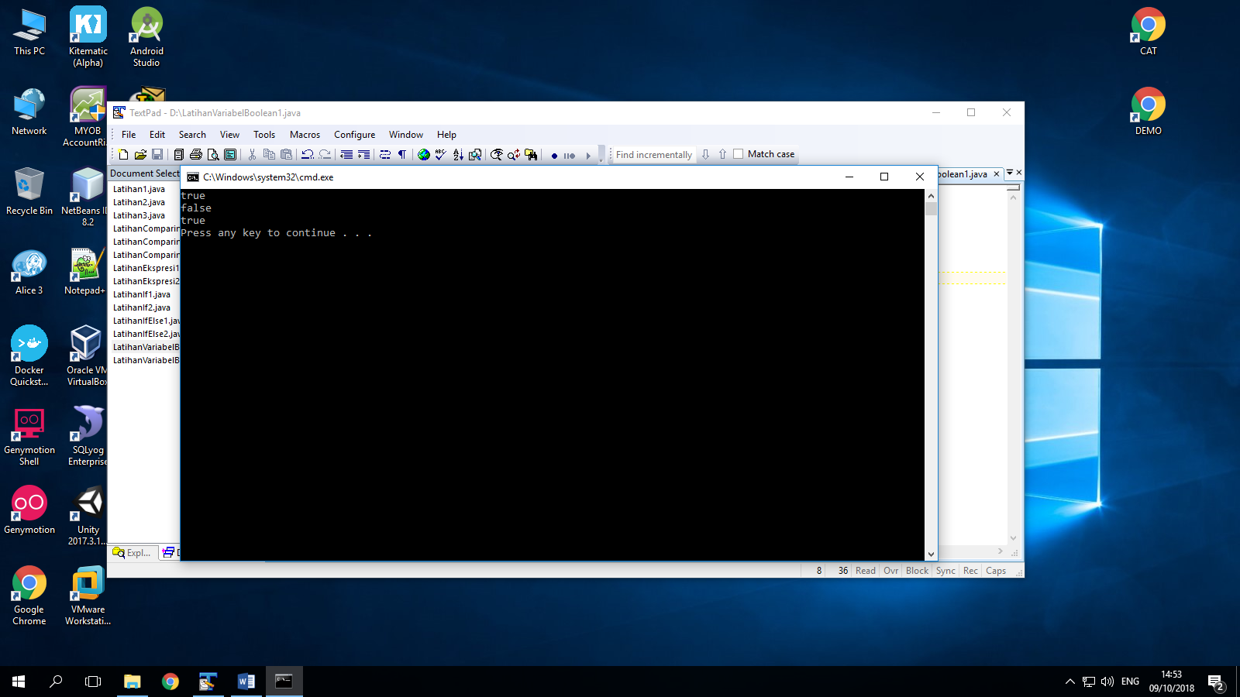

1. Boolean data type scenario

public class LatihanVariabelBoolean2{

public static void main(String[]args){

String left= "museum";

String straight= "gym";

String right= "restaurant";

boolean isLeft= false;

boolean isStraight= true;

boolean isRight= false;

System.out.println("Go straight ahead");

}

}

Output :

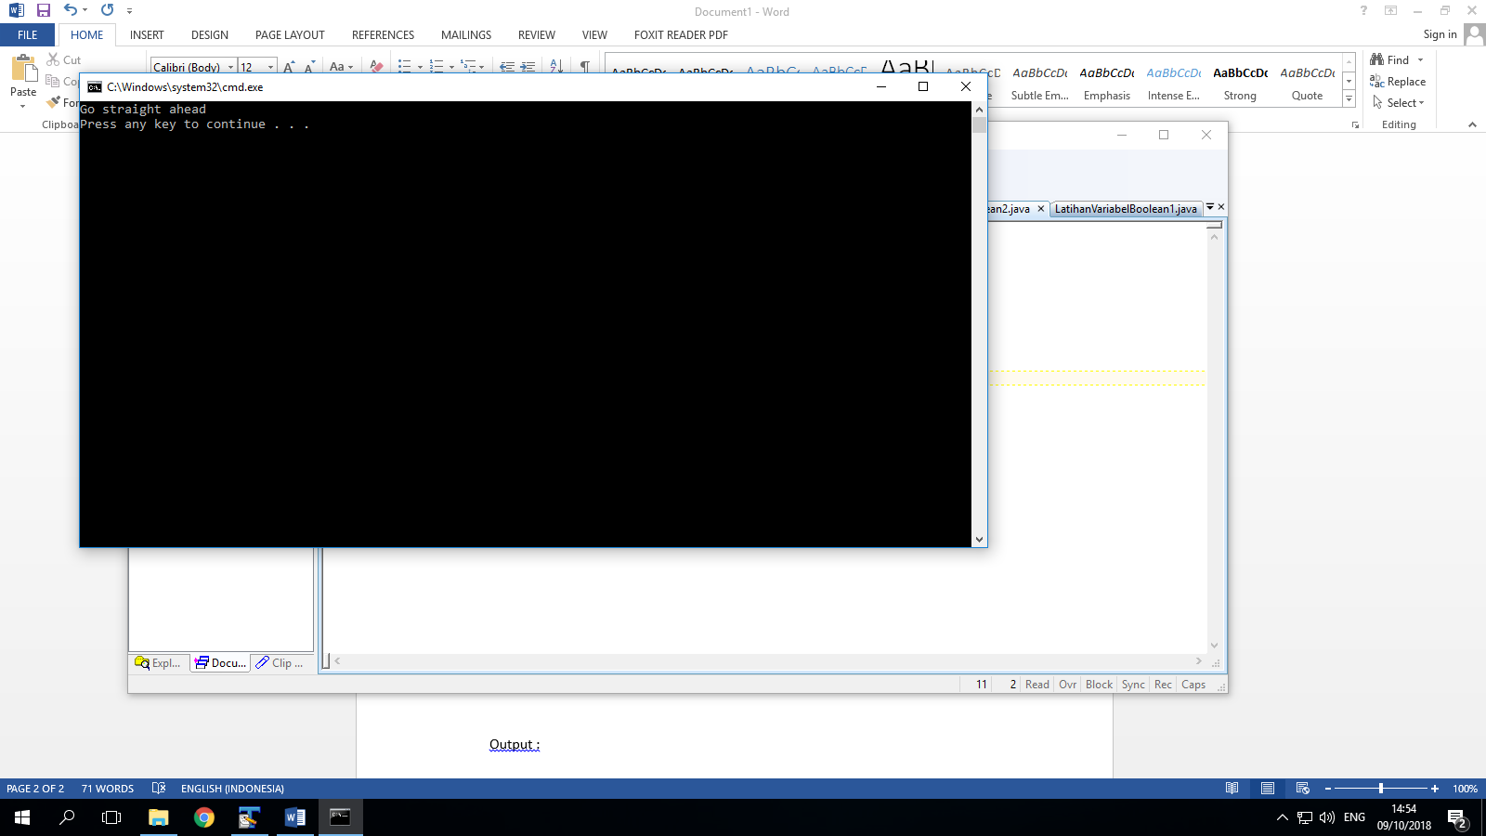

PRAKTIK 2

1. Comparison and task

public class LatihanEkspresi1{

public static void main(String[]args){

int x= 4;

System.out.println(x==5);

boolean isFive= x==5;

System.out.println(isFive);

}

}

Output :

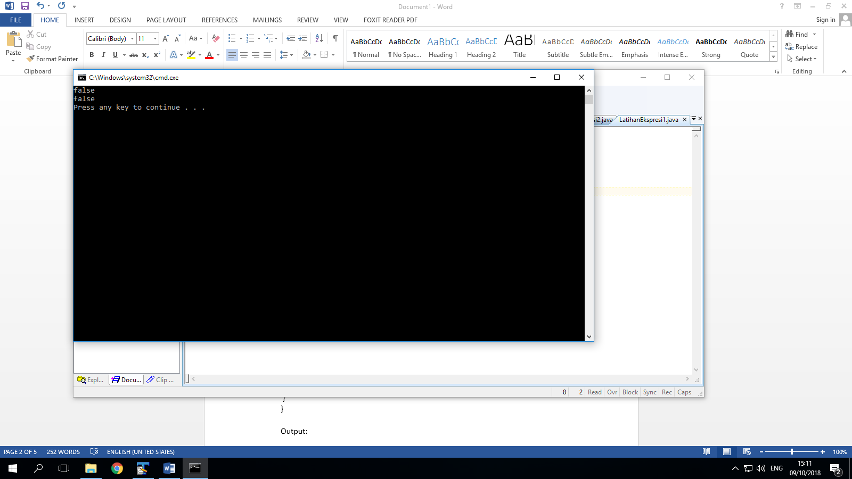

1. Boolean expression

public class LatihanEkspresi2{

public static void main(String[]args){

boolean res1= 24 ==15;

System.out.println("res1: "+res1);

int value1= 15;

int value2= 24;

boolean res2= value1 == value2;

System.out.println("res2:" +res2);

}

}

Output:

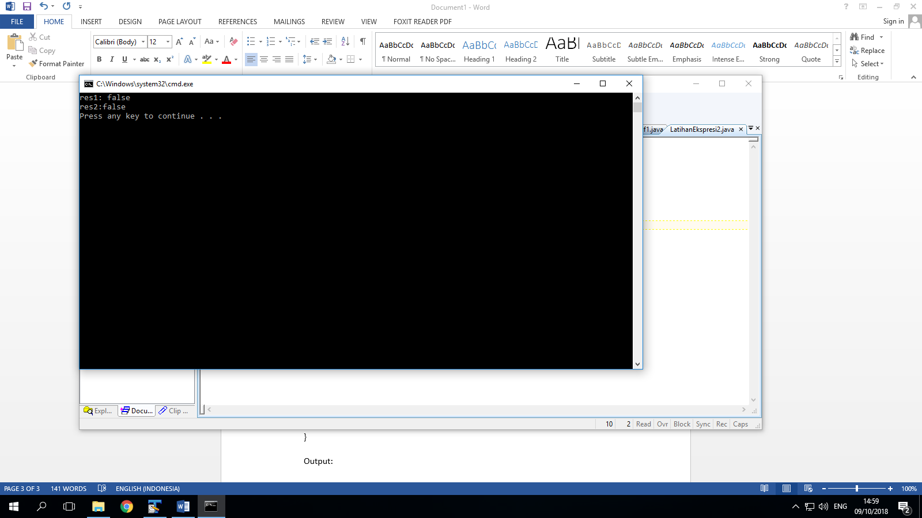

1. Relation operator

public class OperatorRelasi{

public static void main(String[]args){

int a=10;

int b=20;

System.out.println(a==b);

System.out.println(a!=b);

System.out.println(a>b);

System.out.println(a<b);

System.out.println(a>=b);

System.out.println(a<=b);

}

}

Output:

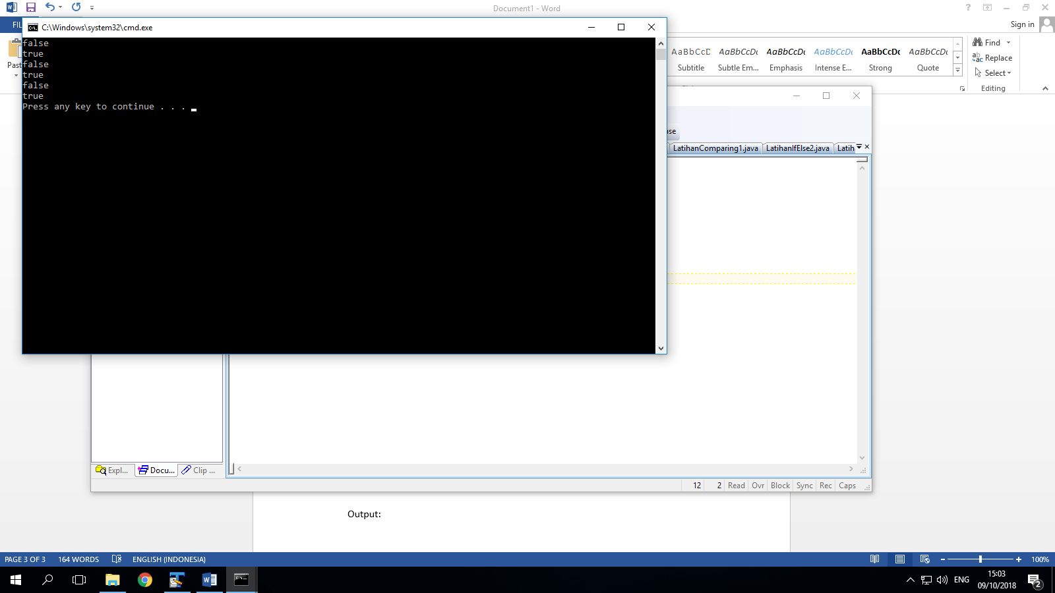

PRAKTIK 3

1. LatihanIf1

public class LatihanIf1{

public static void main(String[]args){

String left= "museum";

String straight= "gym";

String right= "restaurant";

if(left=="gym"){

System.out.println("Turn Left");

}

if(straight=="gym"){

System.out.println("Drive Straight");

}

if(right=="gym"){

System.out.println("Turn Right");

}

}

}

Output:

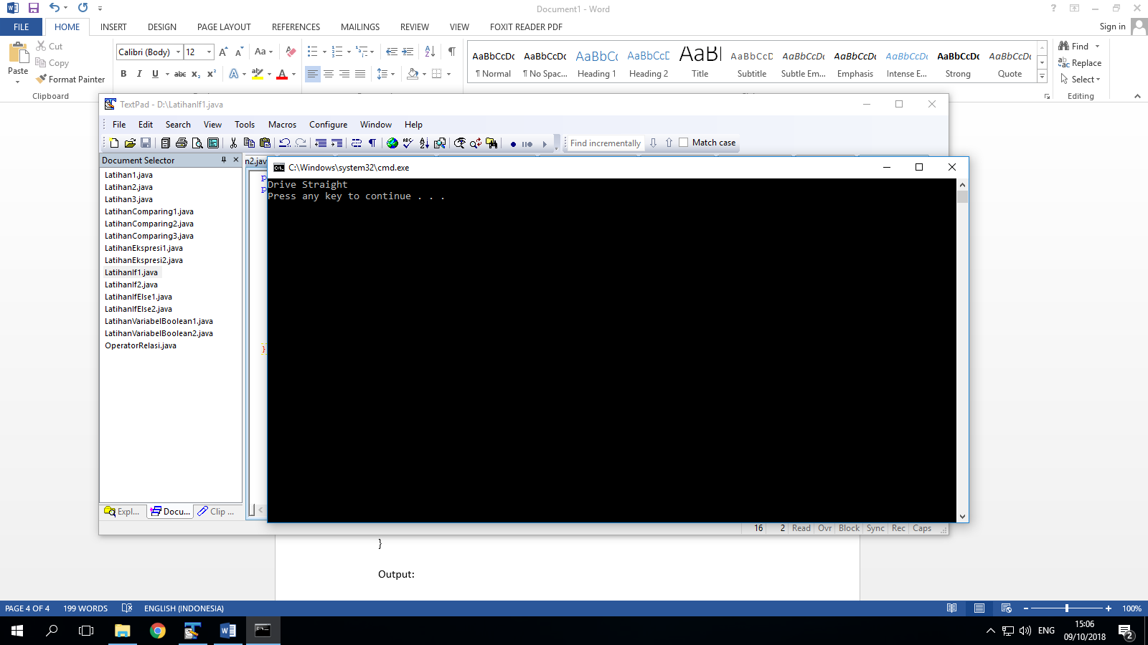

1. LatihanIf2

public class LatihanIf2{

public static void main(String[]args){

int grade= 85;

if (grade>88){

System.out.println("You made the Honor Roll");

}

if(grade<=88){

System.out.println("You are eligible for tutorial");

}

}

}

Output:

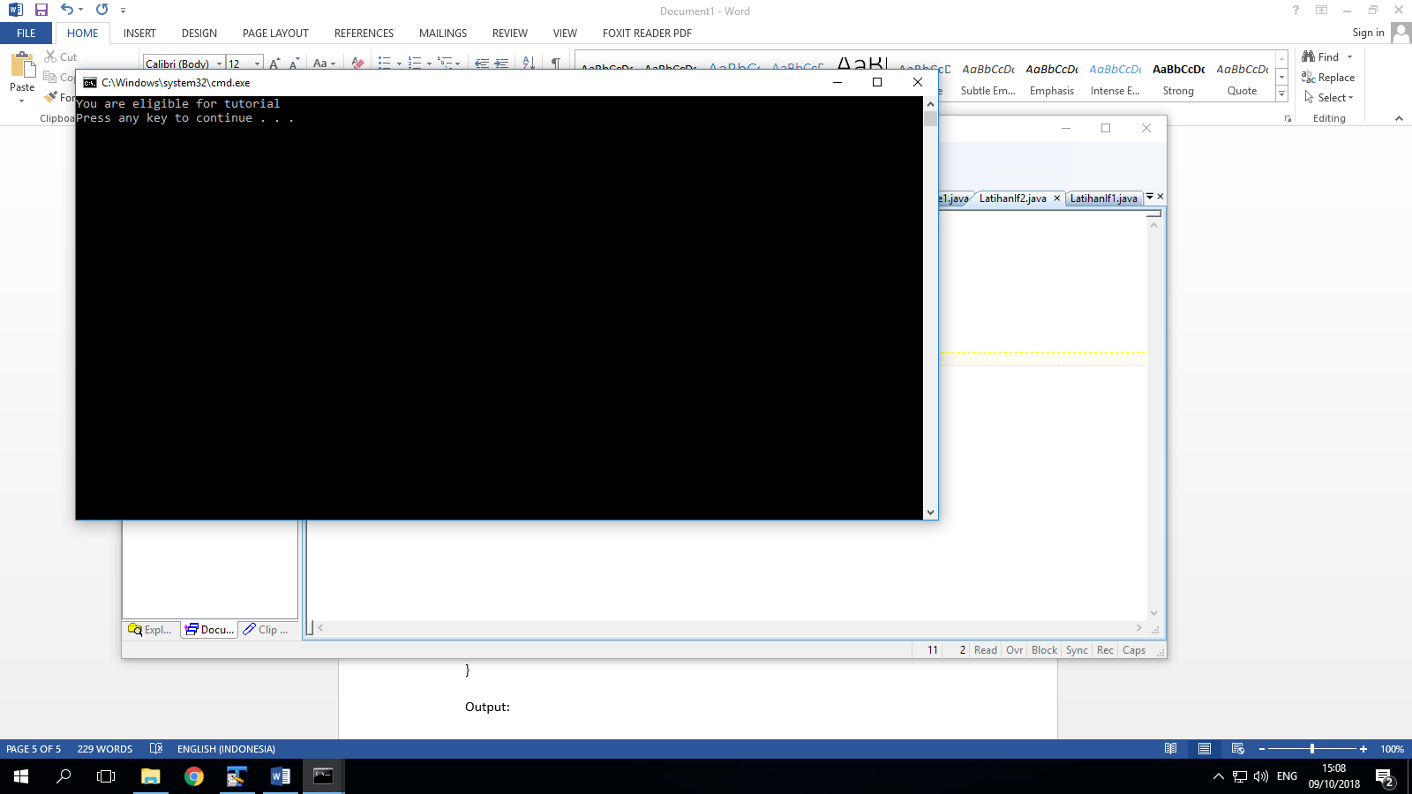

PRAKTEK 4

1. If else stateman

public class LatihanIfElse1{

public static void main(String[]args){

String forecast;

double temperature= getTemperature();

if(temperature<=32.0){

forecast= "SNOW";

}

else{

forecast= "RAIN";

}

System.out.println(forecast);

}

public static double getTemperature(){

return 30.0;

}

}

Output :

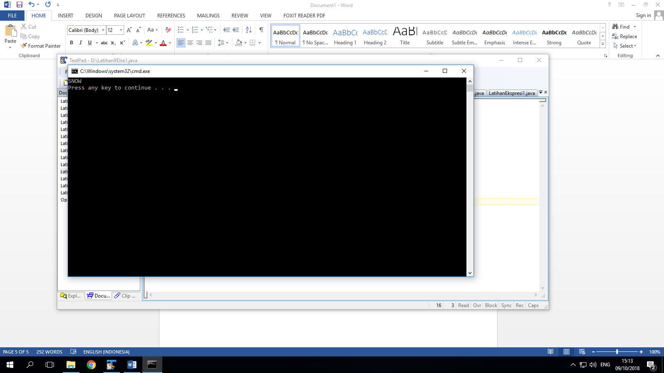

1. If/else statement

public class LatihanIfElse2{

public static void main(String[]args){

int grade= 85;

if(grade>88){

System.out.println("You made the Honor Roll");

}

else{

System.out.println("You Passed");

}

}

}

Output:

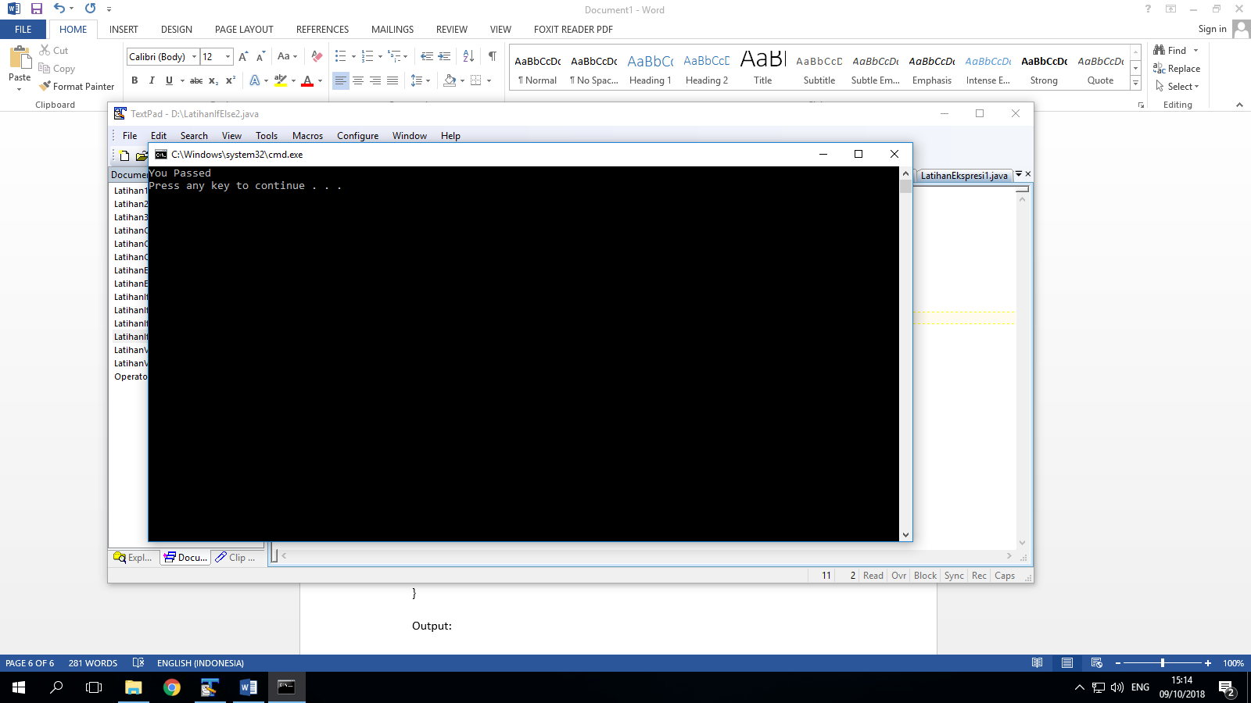

PRAKTIK 5

1. Comparison in primitive variable

public class LatihanComparing1{

public static void main(String[]args){

int x= 3;

int y= 2;

int z= x+y;

boolean test= (z==x+y);

System.out.println(test);

}

}

Output:

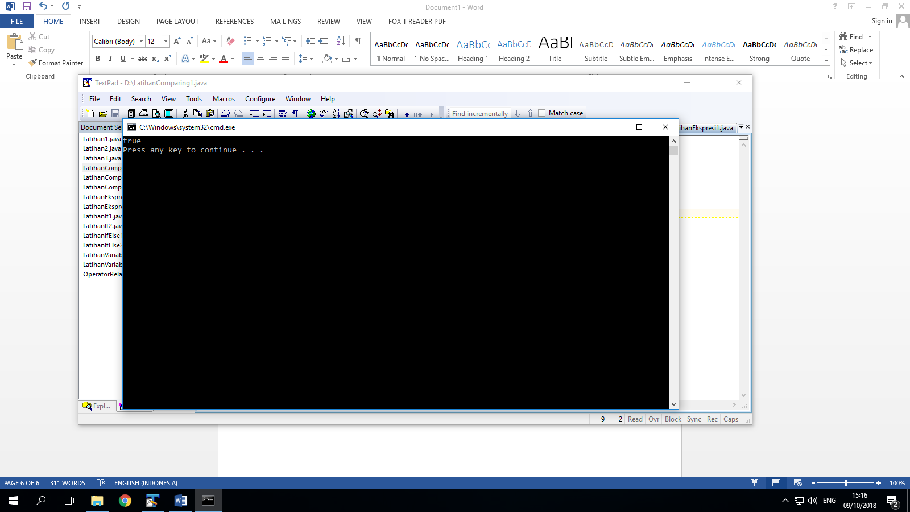

1. Comparison in string

public class LatihanComparing2{

public static void main(String[]args){

String x= "Ora";

String y= "cle";

String z= x+y;

boolean test= (z== x+y);

System.out.println(test);

}

}

Output:

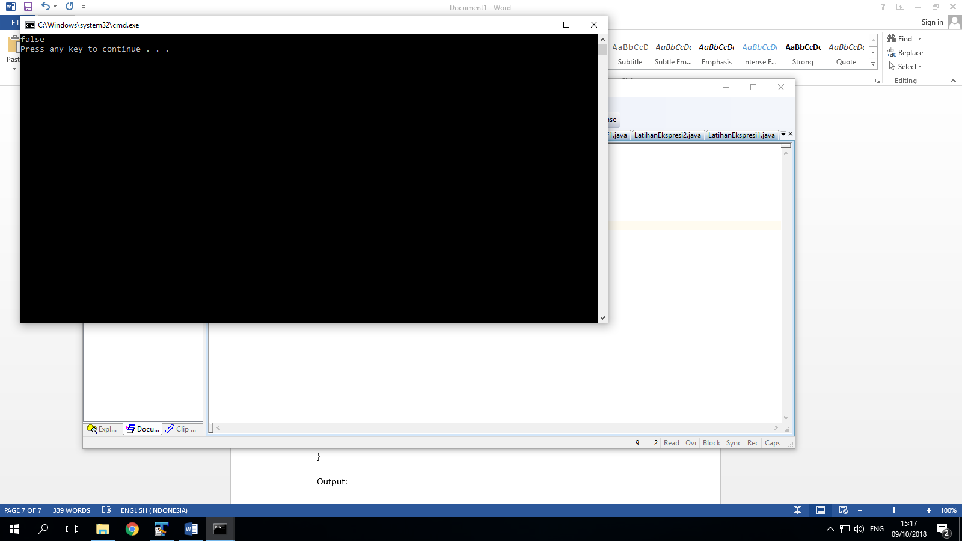

1. Comparison in string value

public class LatihanComparing3{

public static void main(String[]args){

String x= "Ora";

String y= "cle";

String z= x+y;

boolean test= z.equals(x+y);

System.out.println(test);

}

}

Output:

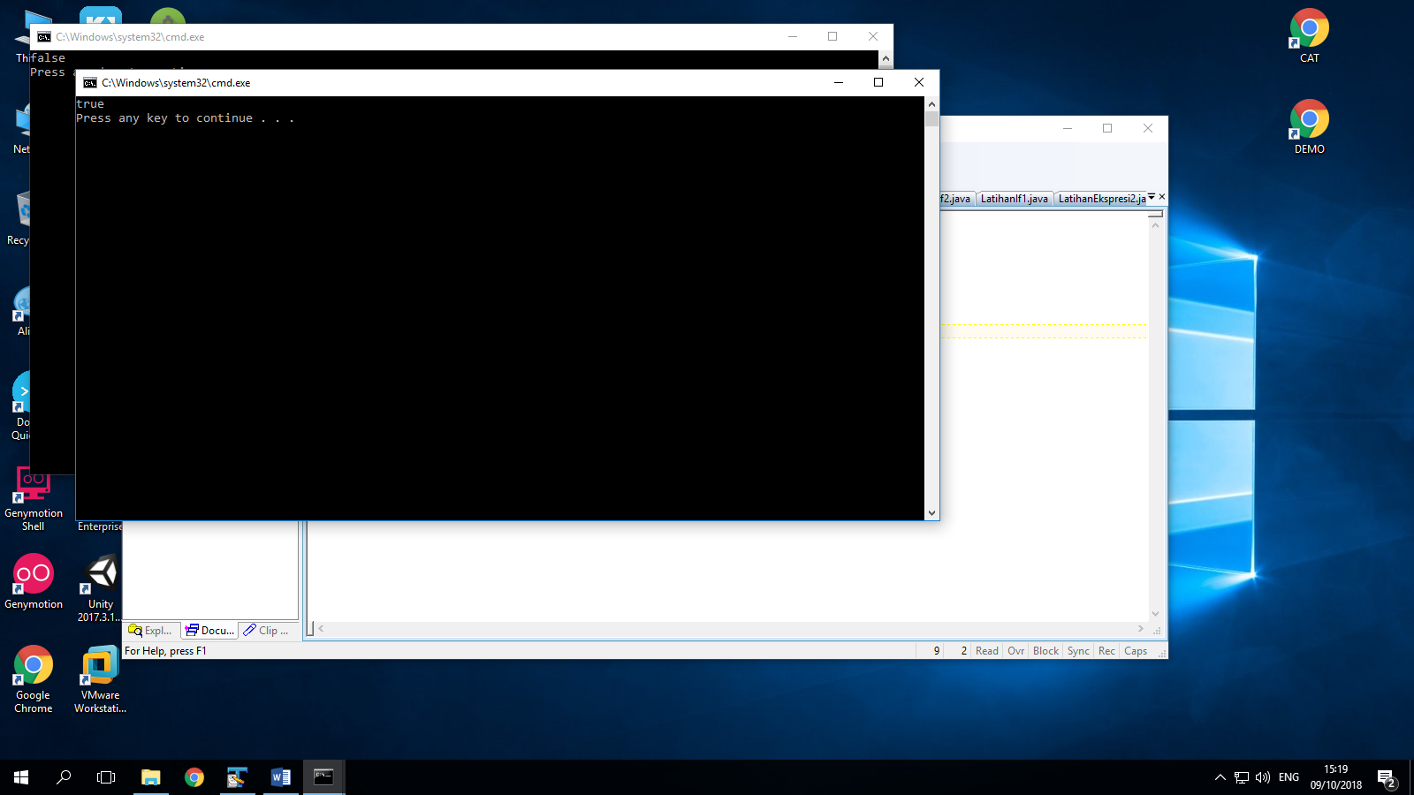

LATIHAN

1. Driving Under Age

import java.util.Scanner;

public class Latihan1{

public static void main(String[]args){

int nAge;

boolean drivingUnderAge;

Scanner input=new Scanner(System.in);

System.out.println("Enter your Age");

nAge= input.nextInt();

drivingUnderAge= false;

if(nAge<=18){

drivingUnderAge= true;

}

System.out.println(drivingUnderAge);

}

}

Output:

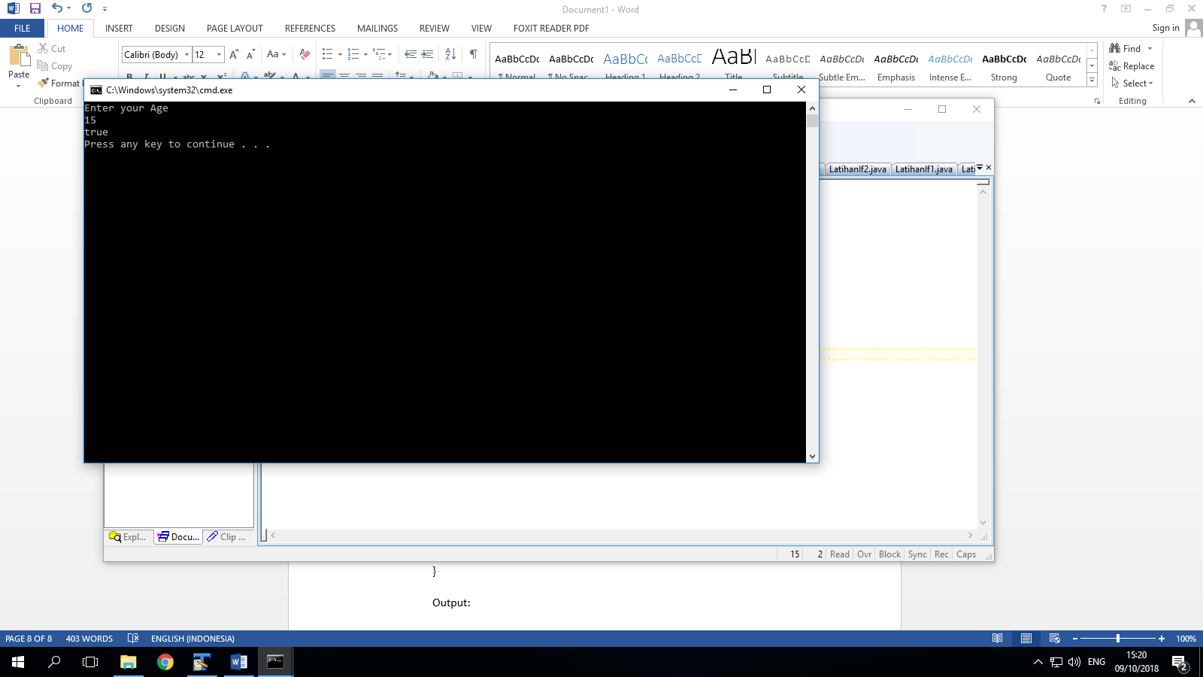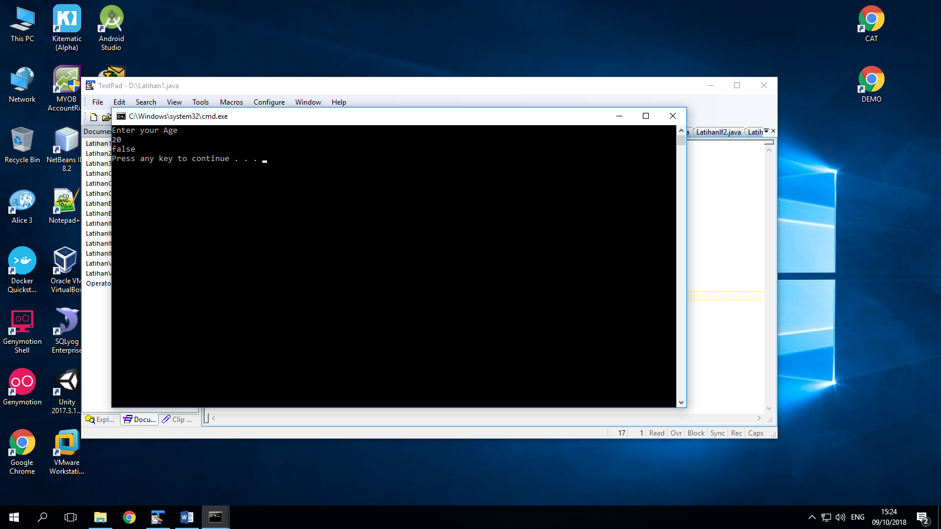

1. Program to check odd or even

import java.util.Scanner;

public class Latihan2{

public static void main(String[]args){

int Nmr;

Scanner input=new Scanner(System.in);

System.out.print("Enter a number:");

Nmr= input.nextInt();

if(Nmr%2==0){

System.out.println("The Num is even " +Nmr);

}

else{

System.out.println("The Num is odd " +Nmr);

}

}

}

Output:

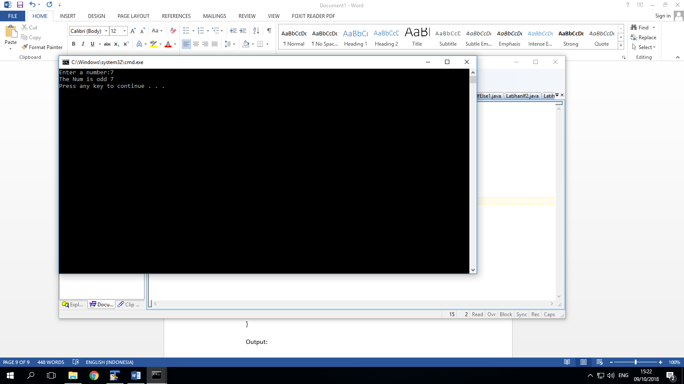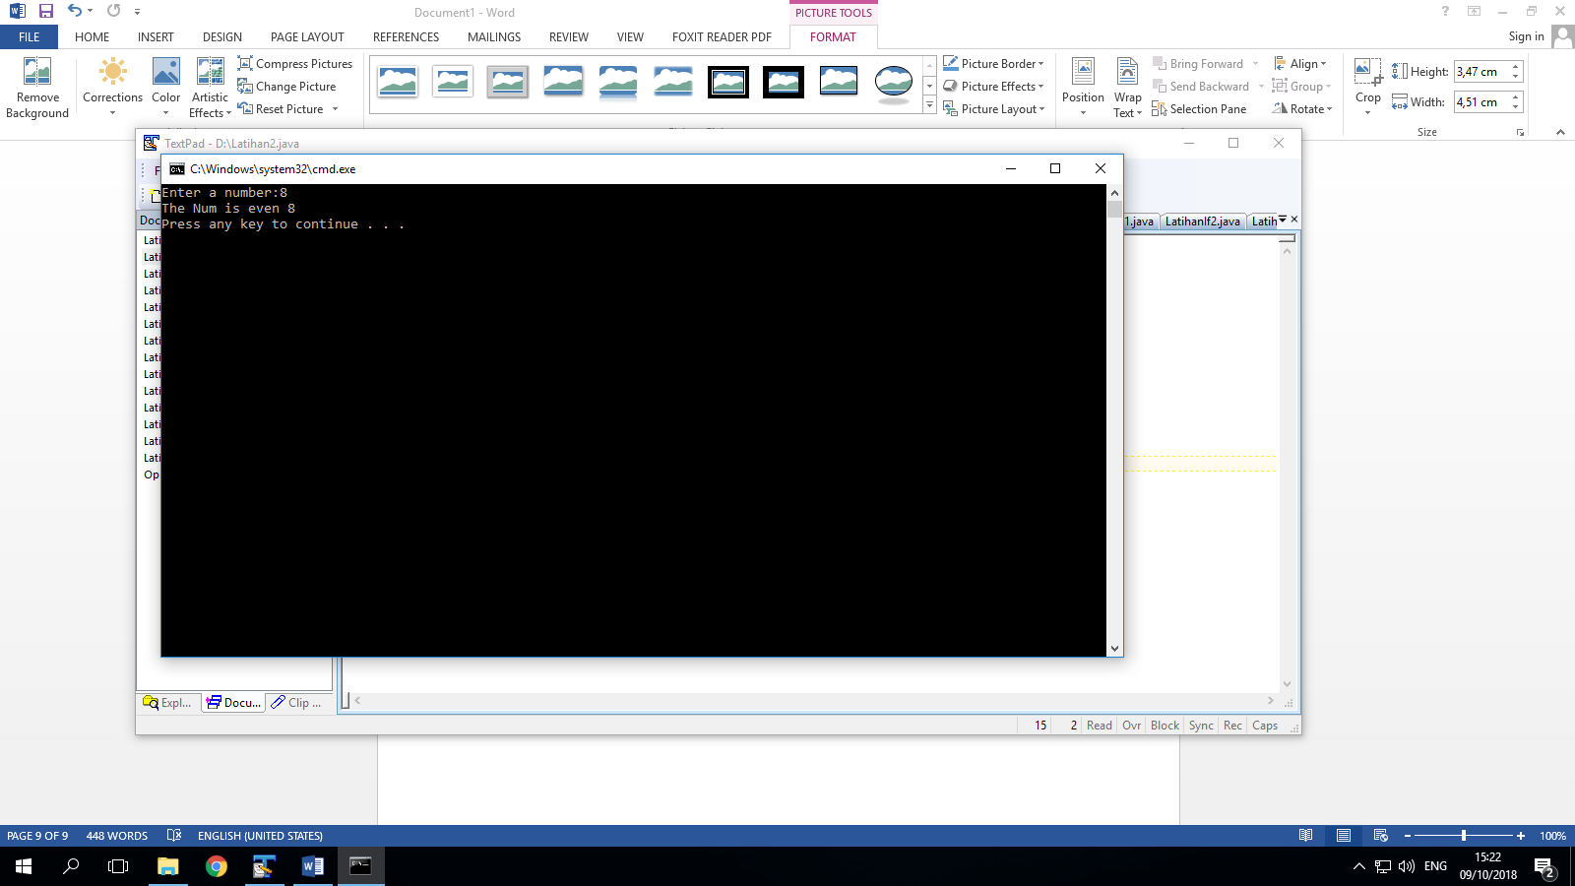

1. Moe is the king rock and roll

import java.util.Scanner;

public class Latihan3{

public static void main(String[]args){

String Nama;

Scanner input=new Scanner(System.in);

System.out.print("Enter your name : ");

Nama= input.next();

if(Nama.equals ("Moe")){

System.out.println("You are the king of rock and roll");

}

else{

System.out.println("You are not the king");

}

}

}

Output:

